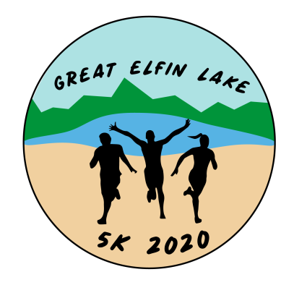

The Great Elfin Lake 5k Run/Walk
Wallingford, Vermont
Sunday May 24, 2020

Dear Local Business Owner:

We are excited to be organizing the 2nd annual Great Elfin Lake 5k Run/Walk in Wallingford, Vermont. Last year, the first annual 5k was a great success with over 120 participants! We invite you to sponsor this health and wellness event, which will benefit the Wallingford Recreation Department and our community.

The event will be held Sunday May 24, 2020. The race will begin at 9 a.m. at the Wallingford Recreational Fields on Meadow Street. This year we will be adding a 1-mile fun run for children ages 10 and under that will begin at 8 a.m. We are seeking out companies and organizations that have an interest in positively affecting the Wallingford community and making our race a success!

Your sponsorship will:
- Encourage people to get out in our community and be active!
- Promote your company/organization (details below)
- Help support the Wallingford Recreation Department

Sponsorship Levels
White Rocks Sponsor - $250 +
- Your company/organization name and logo included on the race t-shirt
- Your company/organization name included in social media advertising
- Receive 2 complimentary 5k registrations

Boy with the Boot Sponsor - $125 +
- Your company/organization name listed on the race t-shirt
- Your company/organization name included in social media advertising
- Receive 1 complimentary 5k registration

Stone Meadow Sponsor - $75 +
- Your company/organization name included in social media advertising

Thank you in advance for your consideration of becoming an event sponsor! Please call or email me if you have any questions.

Respectfully,

Kelly DiIonno, Race Director kelly5krace@gmail.com
(802) 345-2358

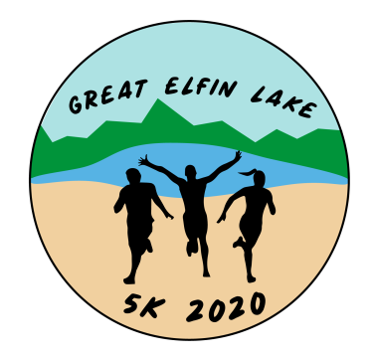

The Great Elfin Lake 5k Run/Walk
Wallingford, Vermont
Sunday May 24, 2020

Please complete the information below:

___ White Rocks Sponsor - $250 +
___ Boy with the Boot Sponsor - $125 +
___ Stone Meadow Sponsor - $75 +

Name of Sponsor: ___________________________________________________________________________________

Address: __________________________________________________________________________________________

Contact Person: _________________________________________________Phone Number: ______________________

Checks payable to:
Wallingford Recreation Department
75 School Street
Wallingford, Vermont 05773

